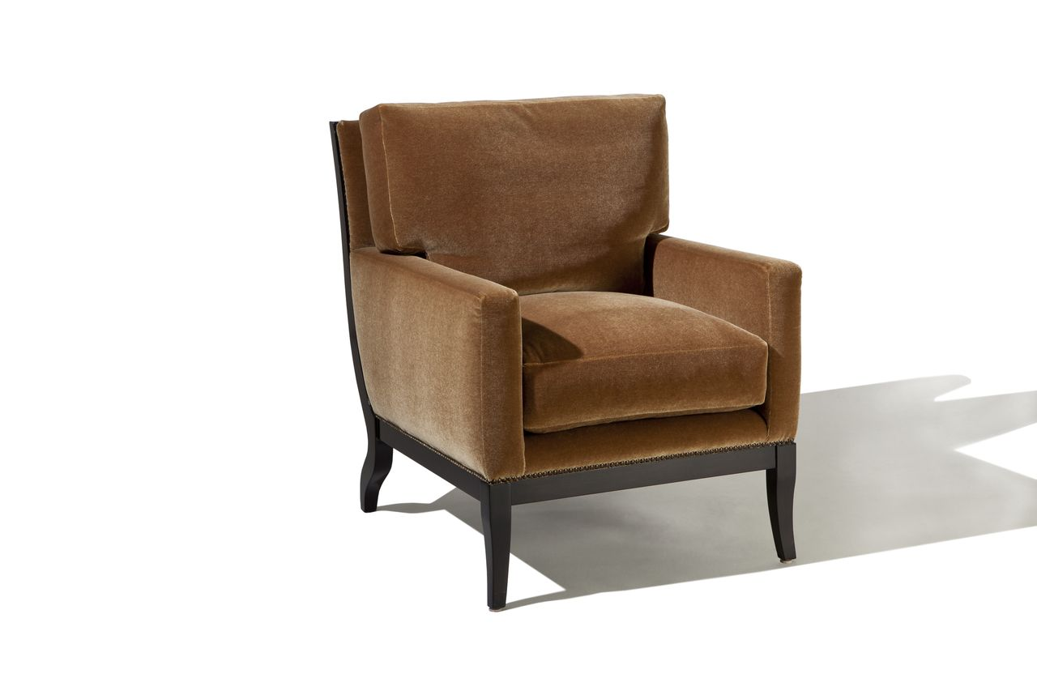

31st Street Chair
Apx: 29w x 39d x 37h
COM: 8 yards

