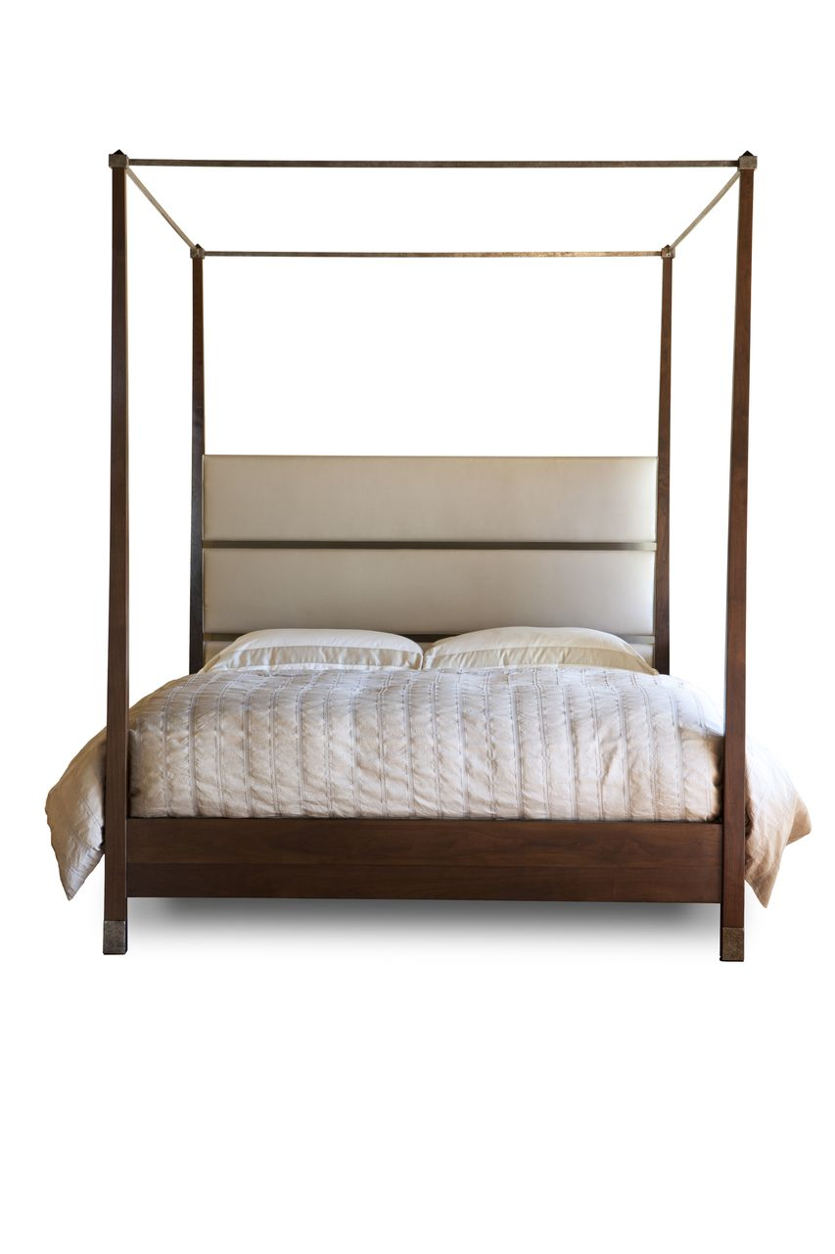

Aria Bed
Cal. King Shown
COM: 5 yards
Shown in Natural Walnut

