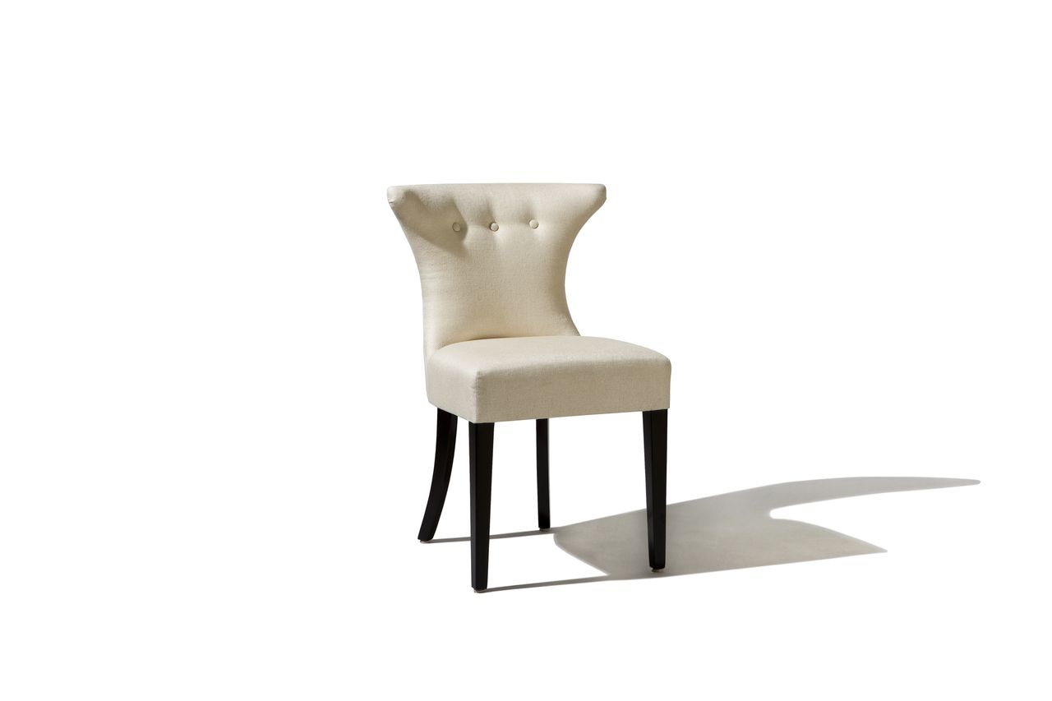

Astro Chair
22w x 21.5d x 34H
COM: 3 yards
COL: 54 square Feet

