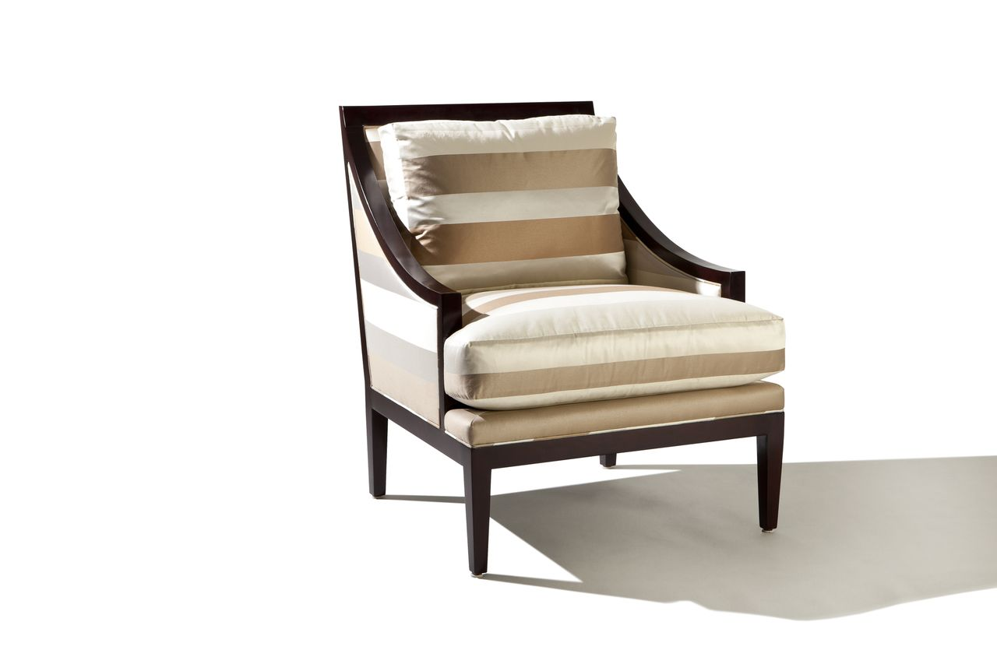

Avendale Chair
31w x 38d x 36H
COM: 7 yards

