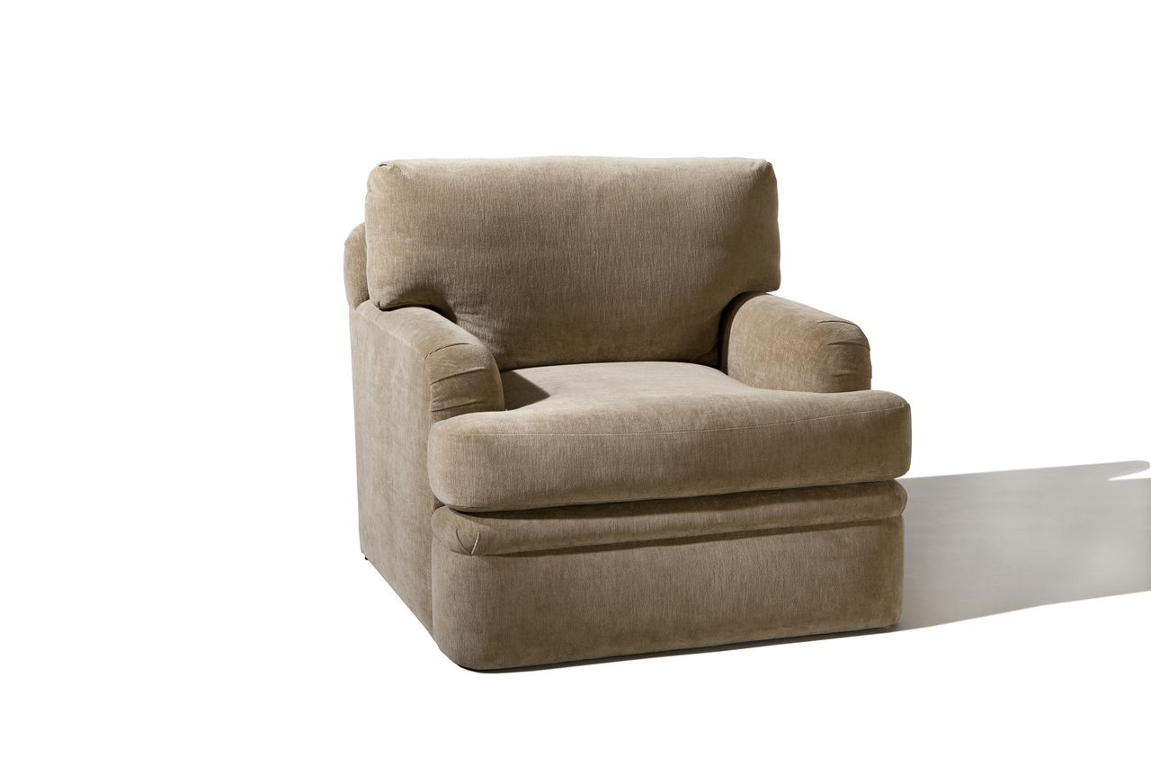

Bending Lounge Chair
36w x 39d x 30H
COM: 10 yards

