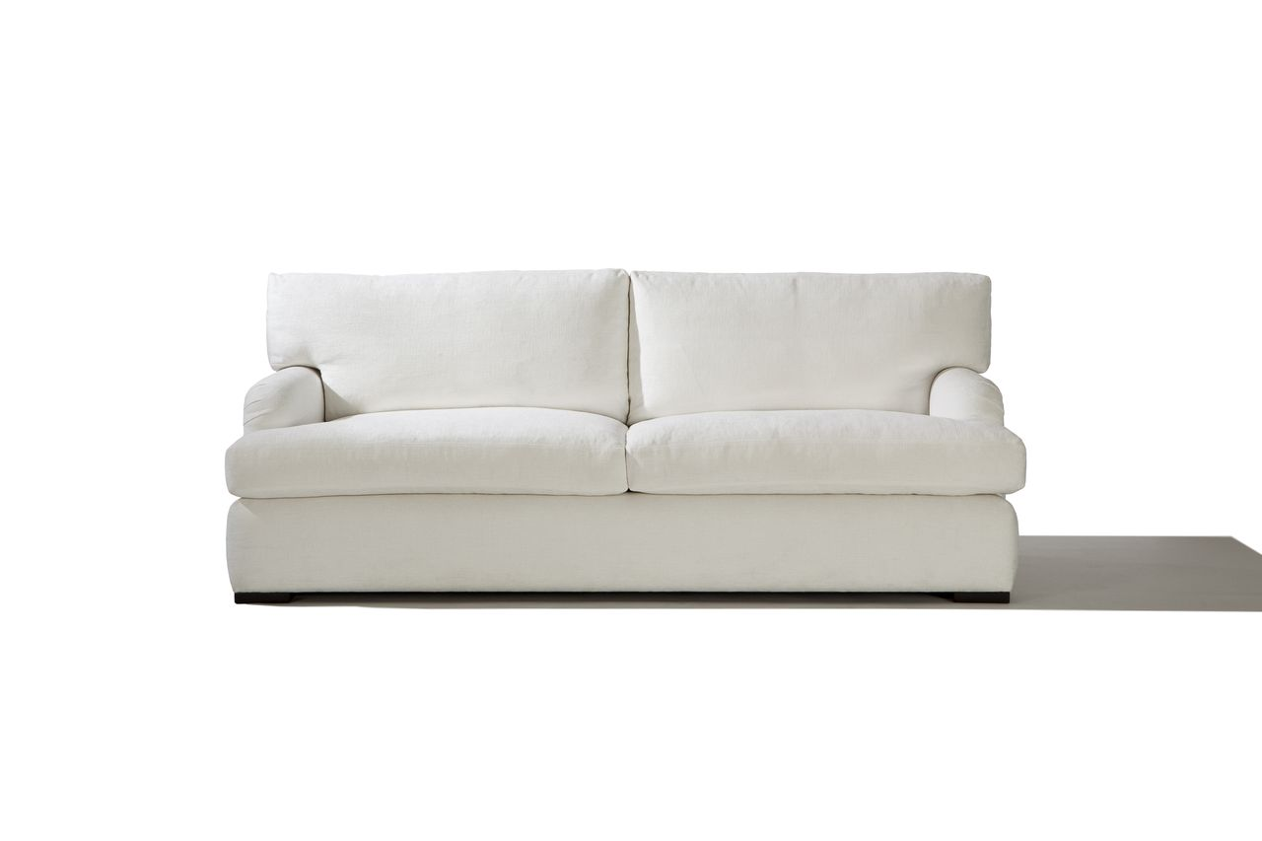

Bending Sofa Chair
84w x 39d x 30H
COM: 21 yards
Custom Sizing Available

