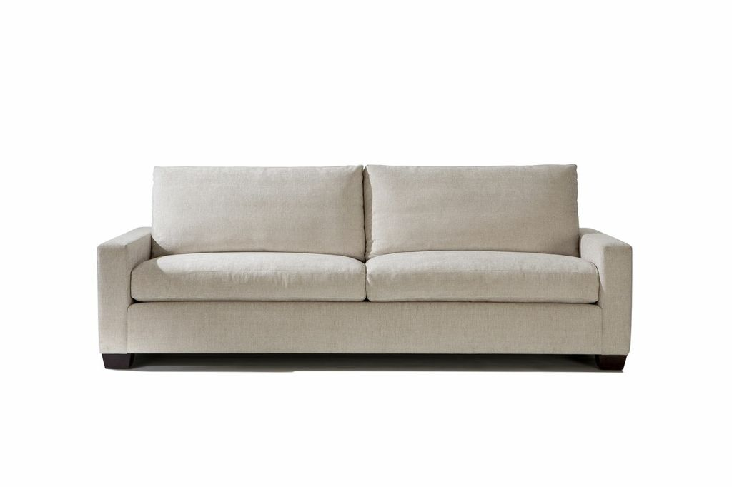

Colette Sofa
Apx: 96w x 40d x 31.5h
COM: 24 yards

