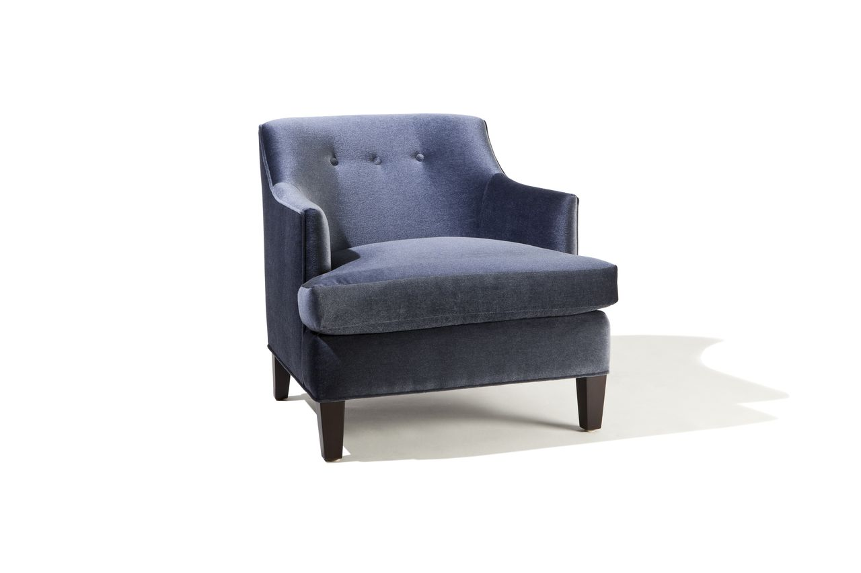

Elisa Chair
32w x 34d x 30H
COM: 6 yards

