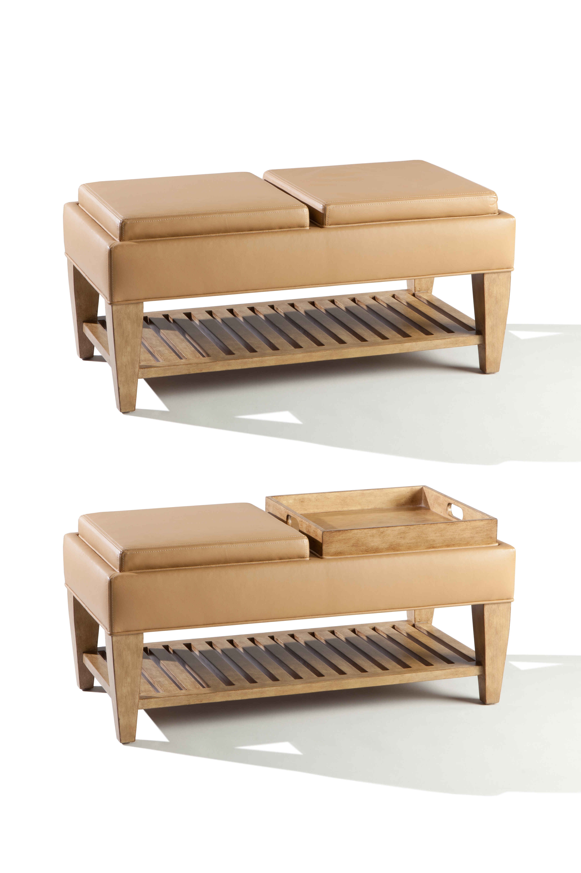

Lido Tray Ottoman
40w x 20d x 19”h
COM: 3 yards
COL: 54 square Feet

