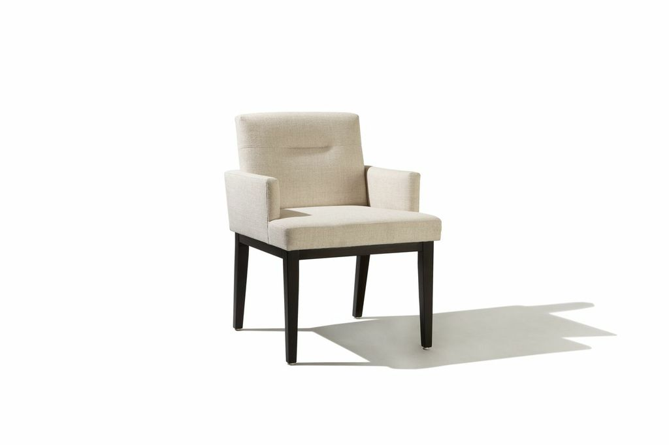

Mondrian Arm Chair
25w x 27d x 35H
COM: 3 yards
COL: 54 square Feet

