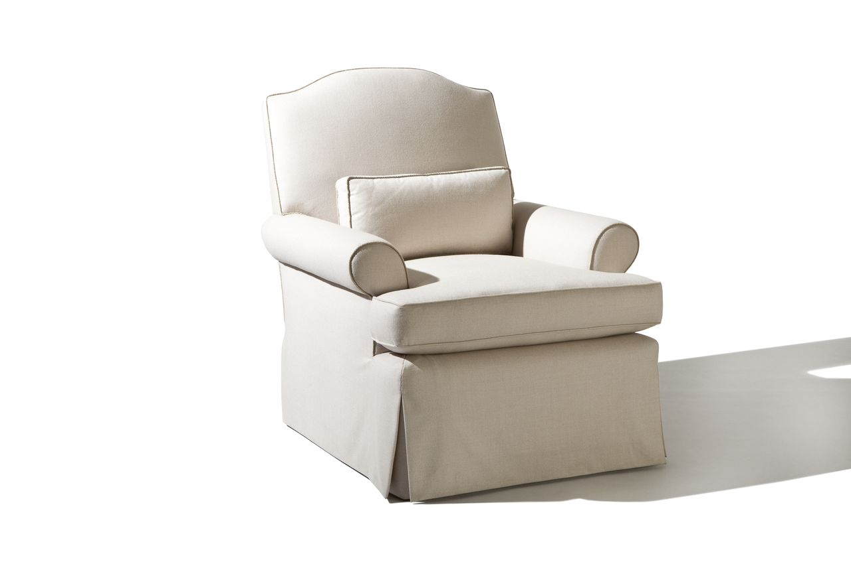

Pacific Lounge Chair
33w x 42d x 40H
COM: 10 yards
Custom Sizing Available

