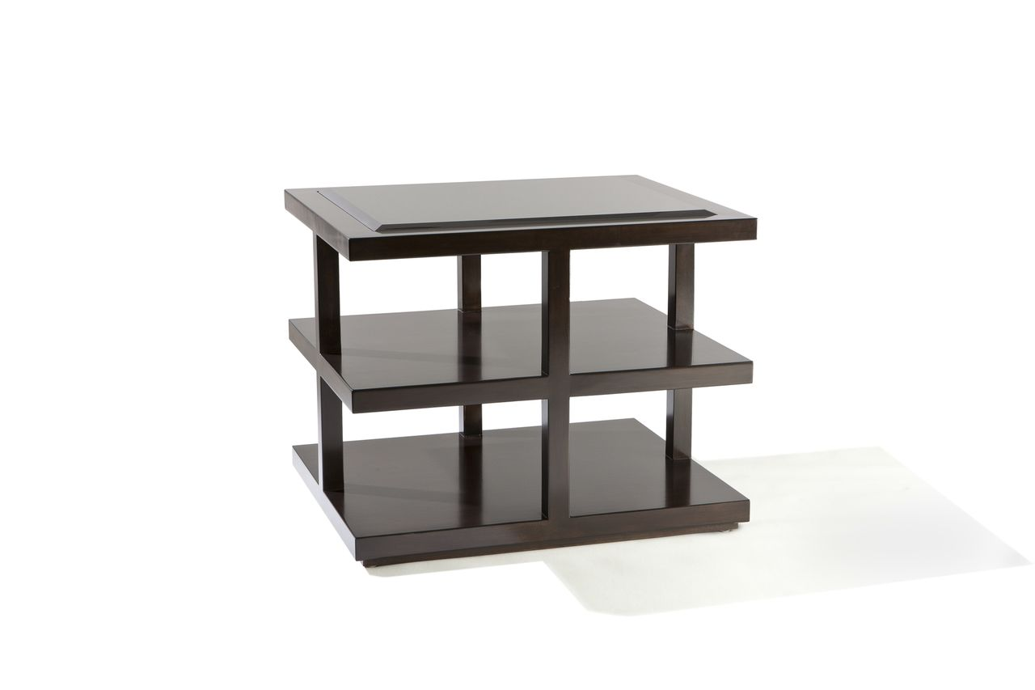

Rockefeller Side Table
36w x 28d x 26H
Custom Sizing Available

